**Creating Persistence Unit in NetBeans**

**Step 1:** Create the MySQL database and connection in NetBeans.

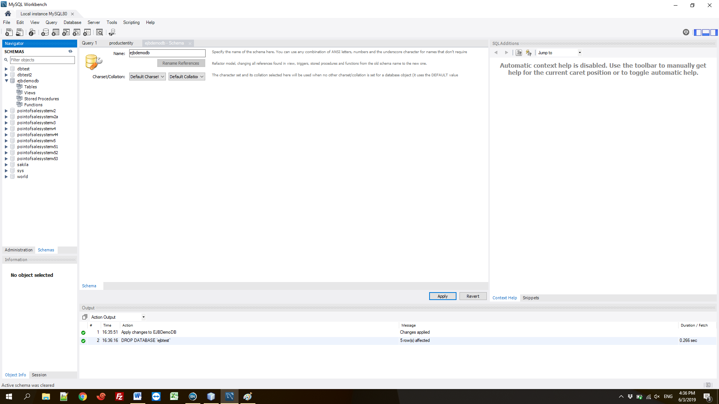

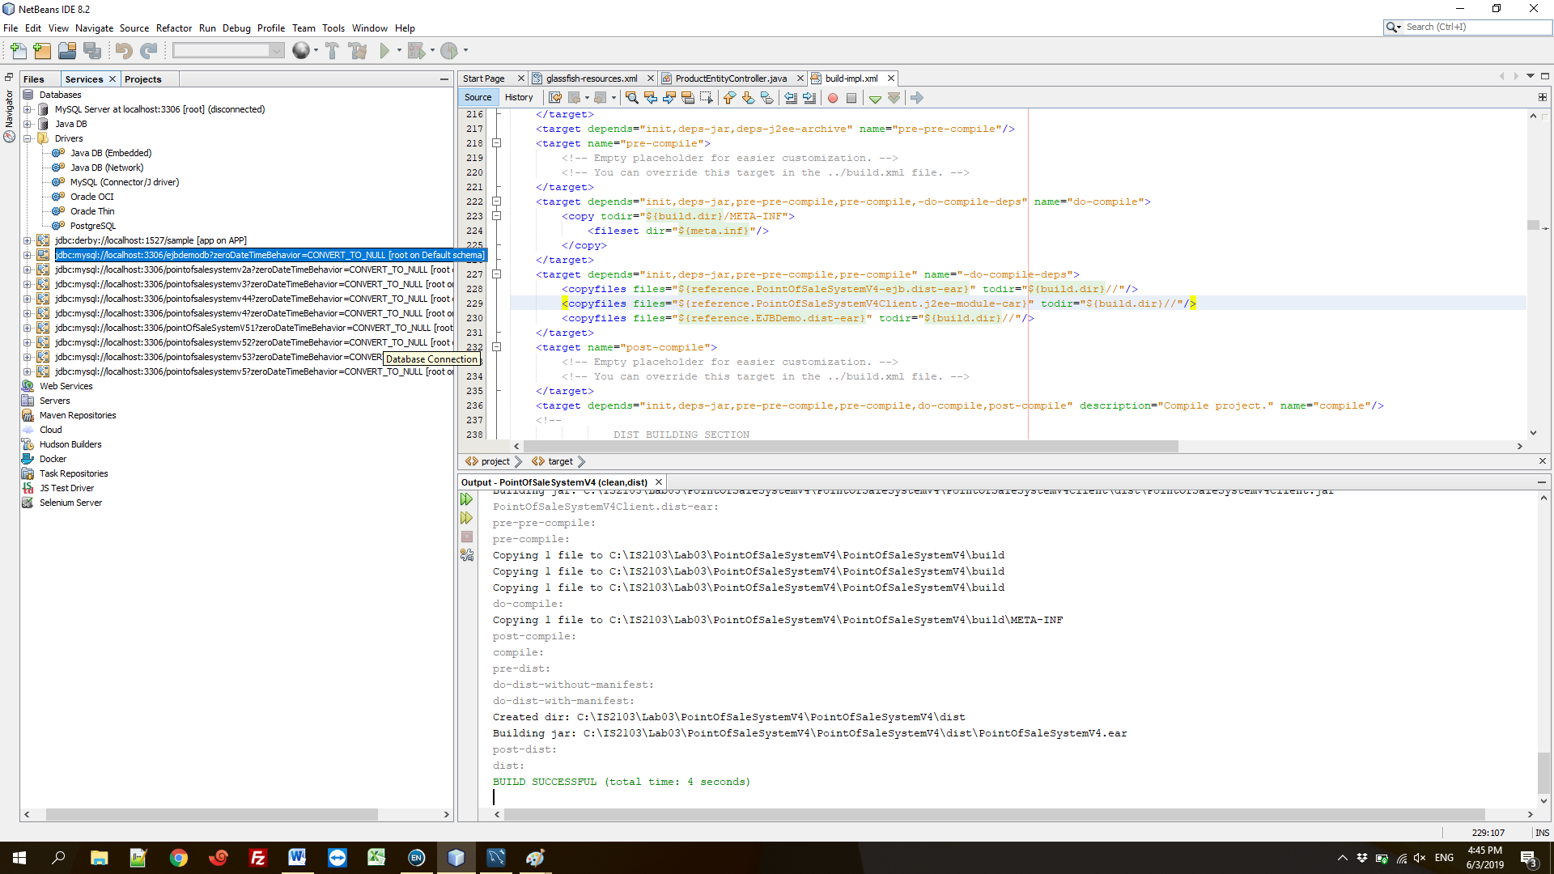

**Step 2:** Create datasource and connection pool.

Right click on the bean project to create datasource and connection pool as follows.

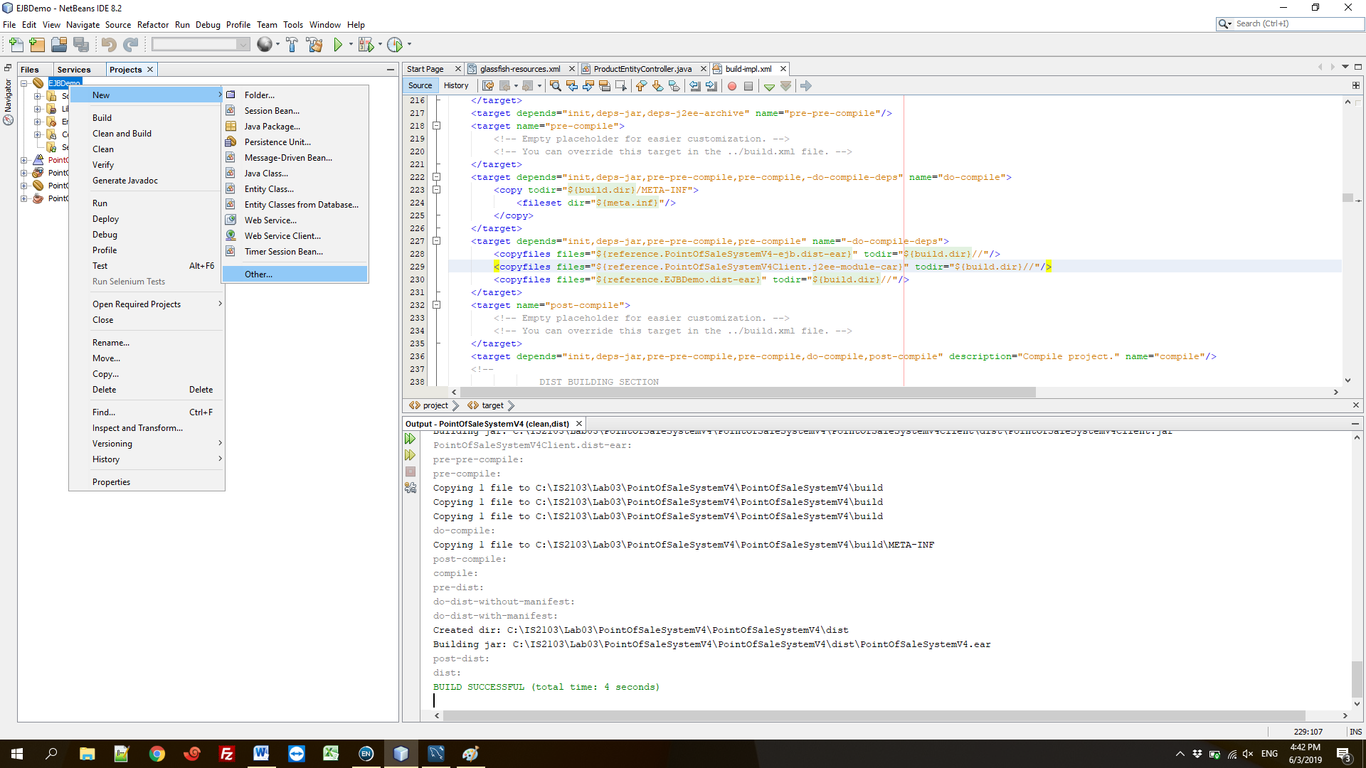

In glassfish subcategory select JDBC resource.

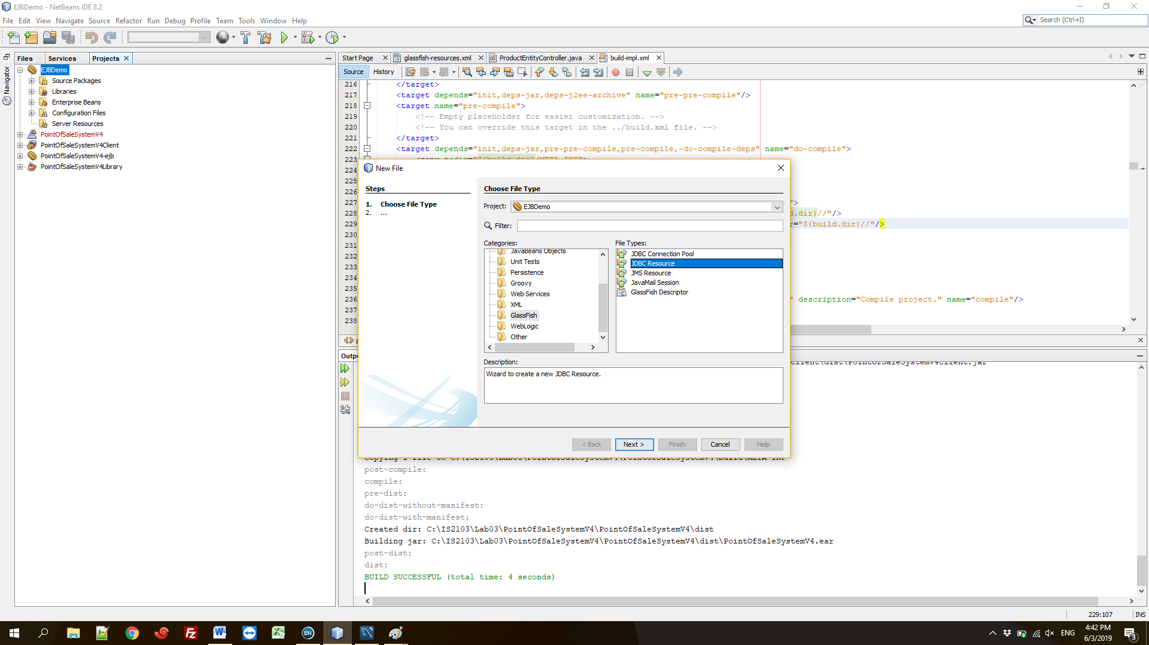

Set datasource name and select to “Create New JDBC Connection Pool”.

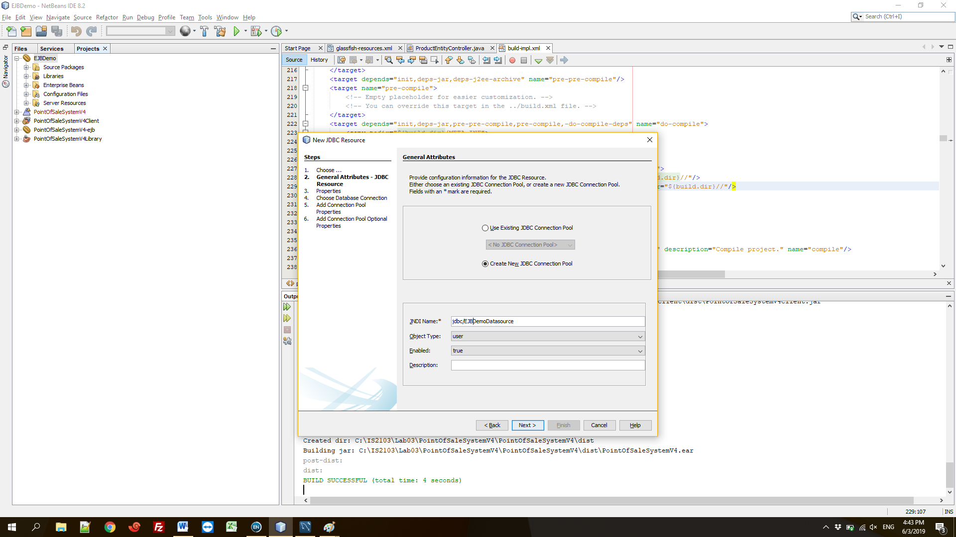

No need to set any additional properties.

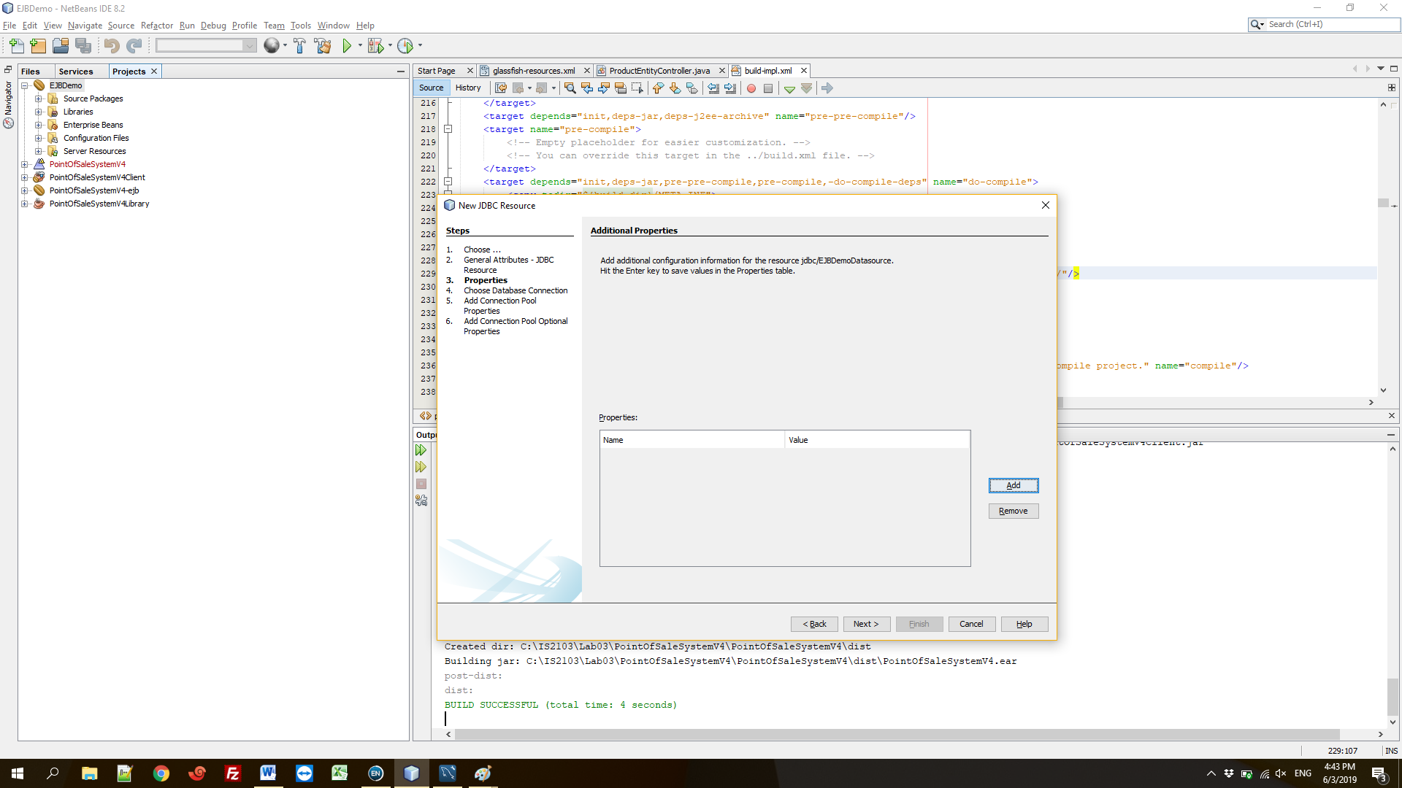

Set connection pool name and select the database connection.

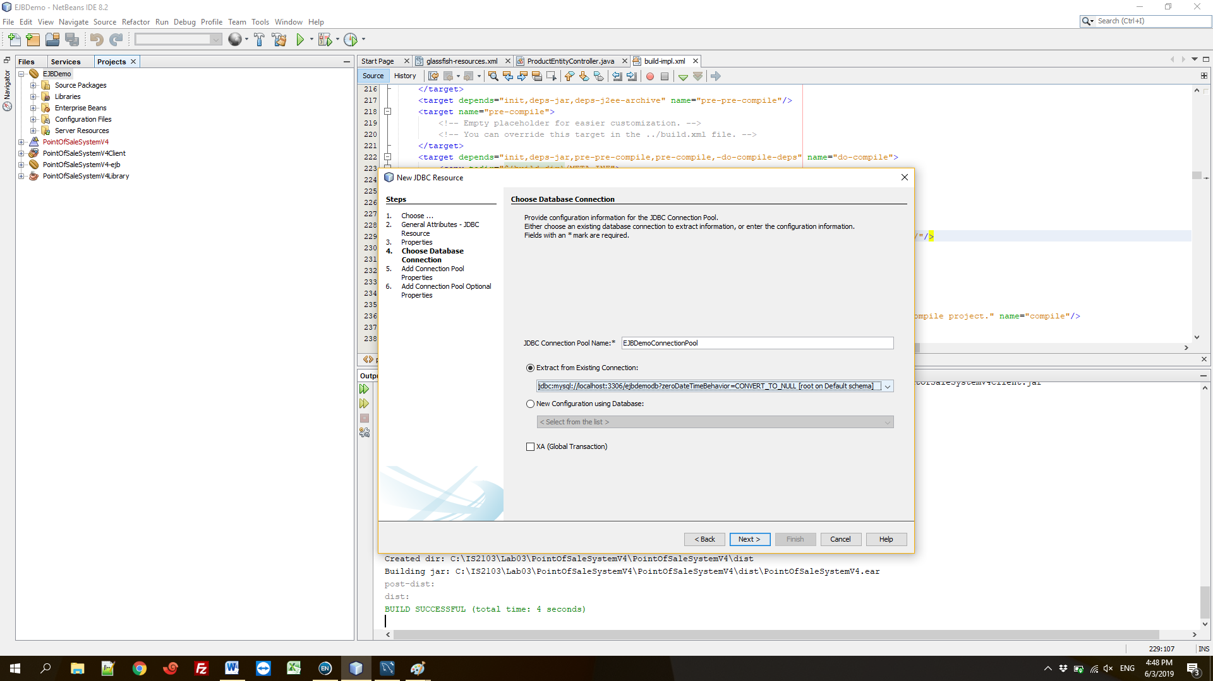

No need to change any further properties. Click next and click finish.

You should be able to see the glassfish-resources.xml file in “Server Resources” folder. If the file doesn’t appear, check “Configuration Files/META-INF” folder. Drag and drop the file to “Server Resources” folder.

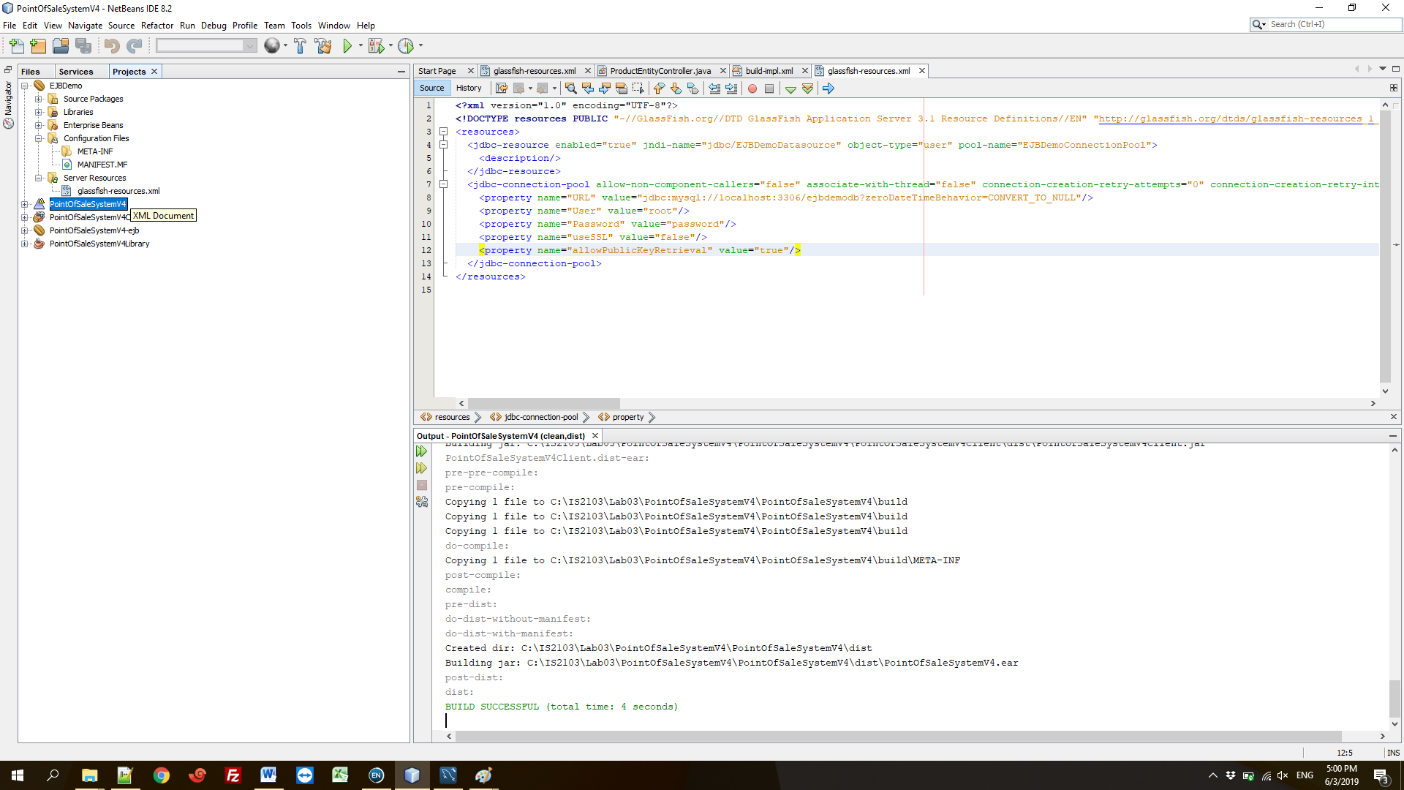

**Step 3:** Create Persistance Unit

Follow the steps.

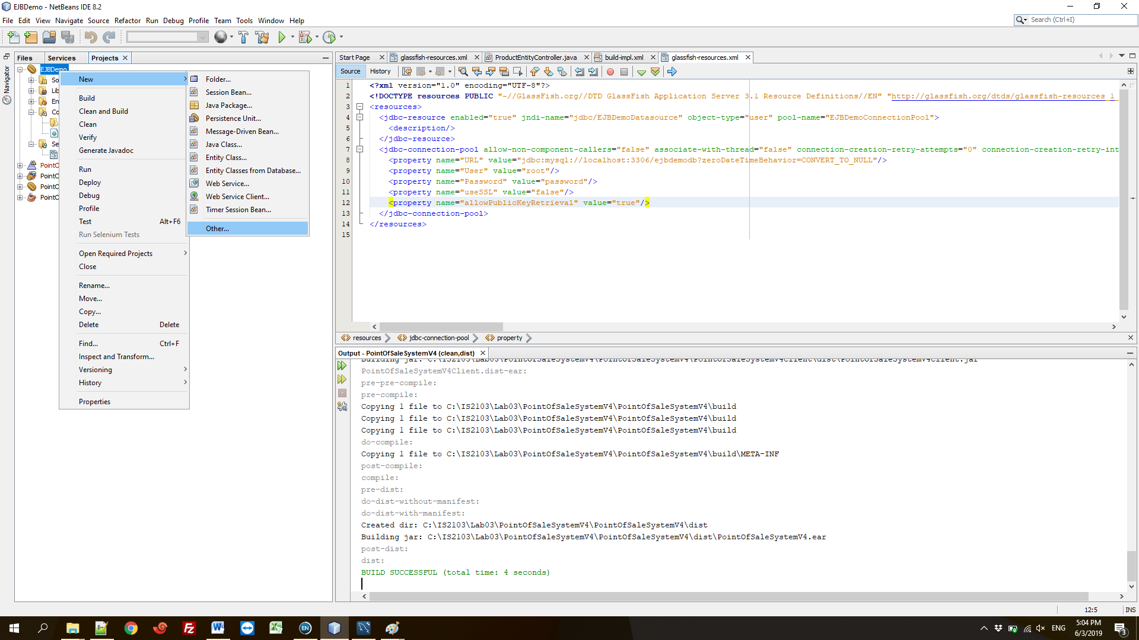

Select Persistance Unit under Persistence.

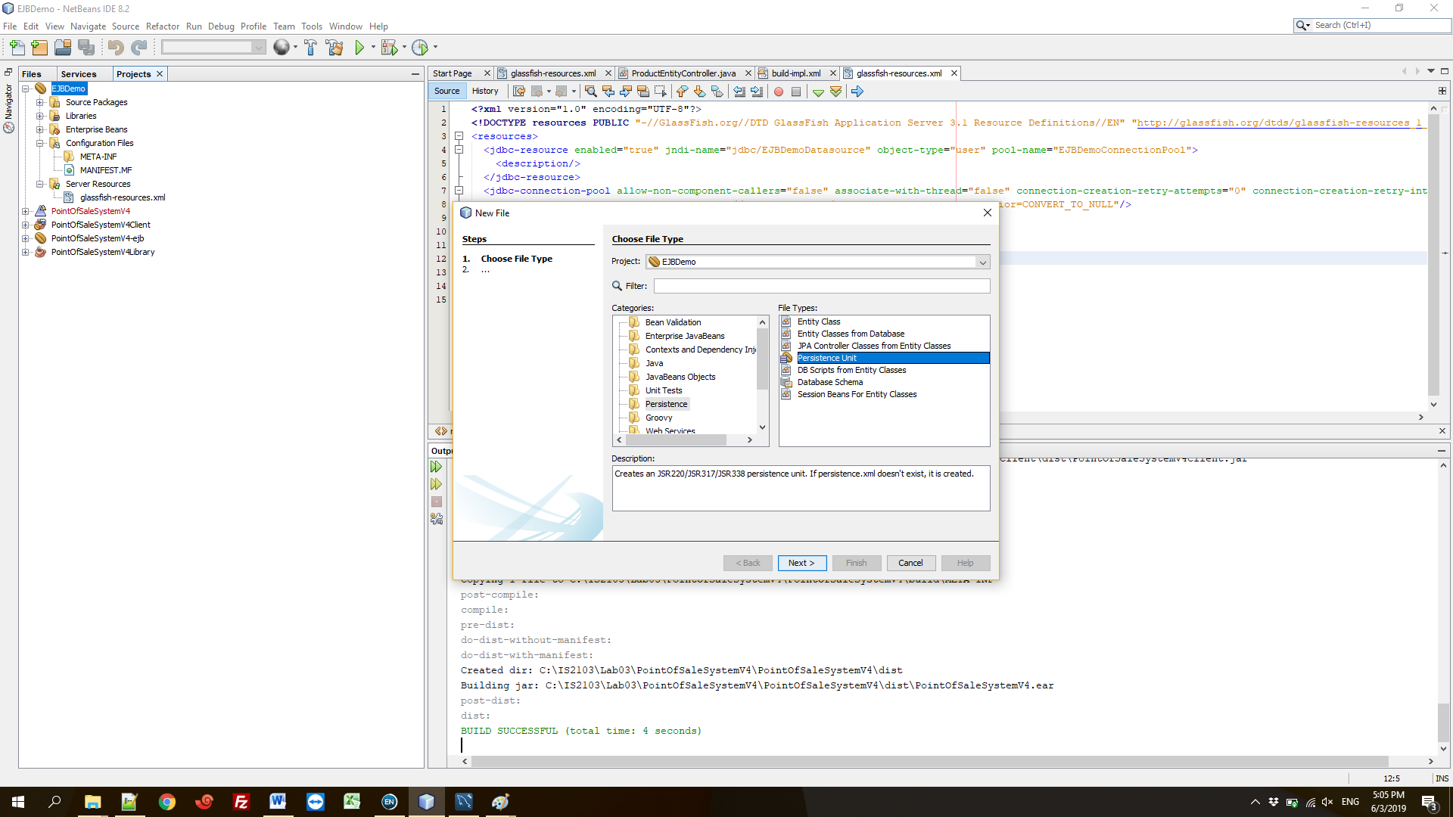

Select the datasource you just created.

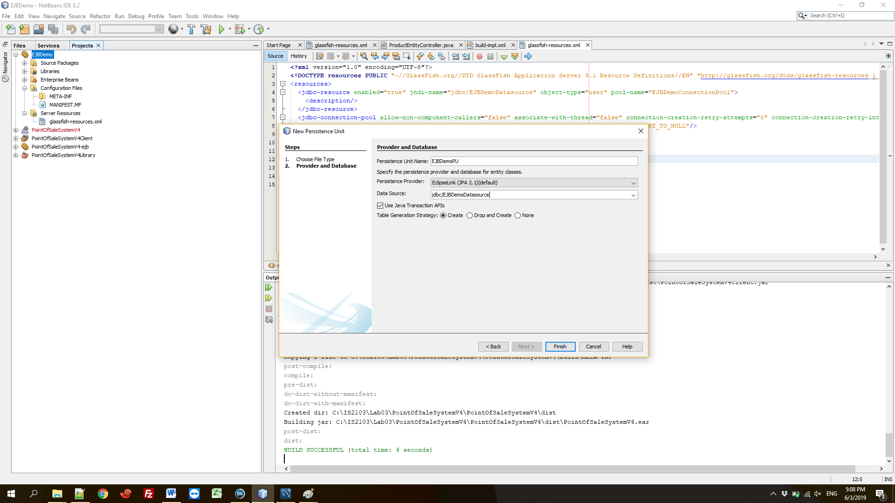

You should be able to see the persistence.xml file as follows.

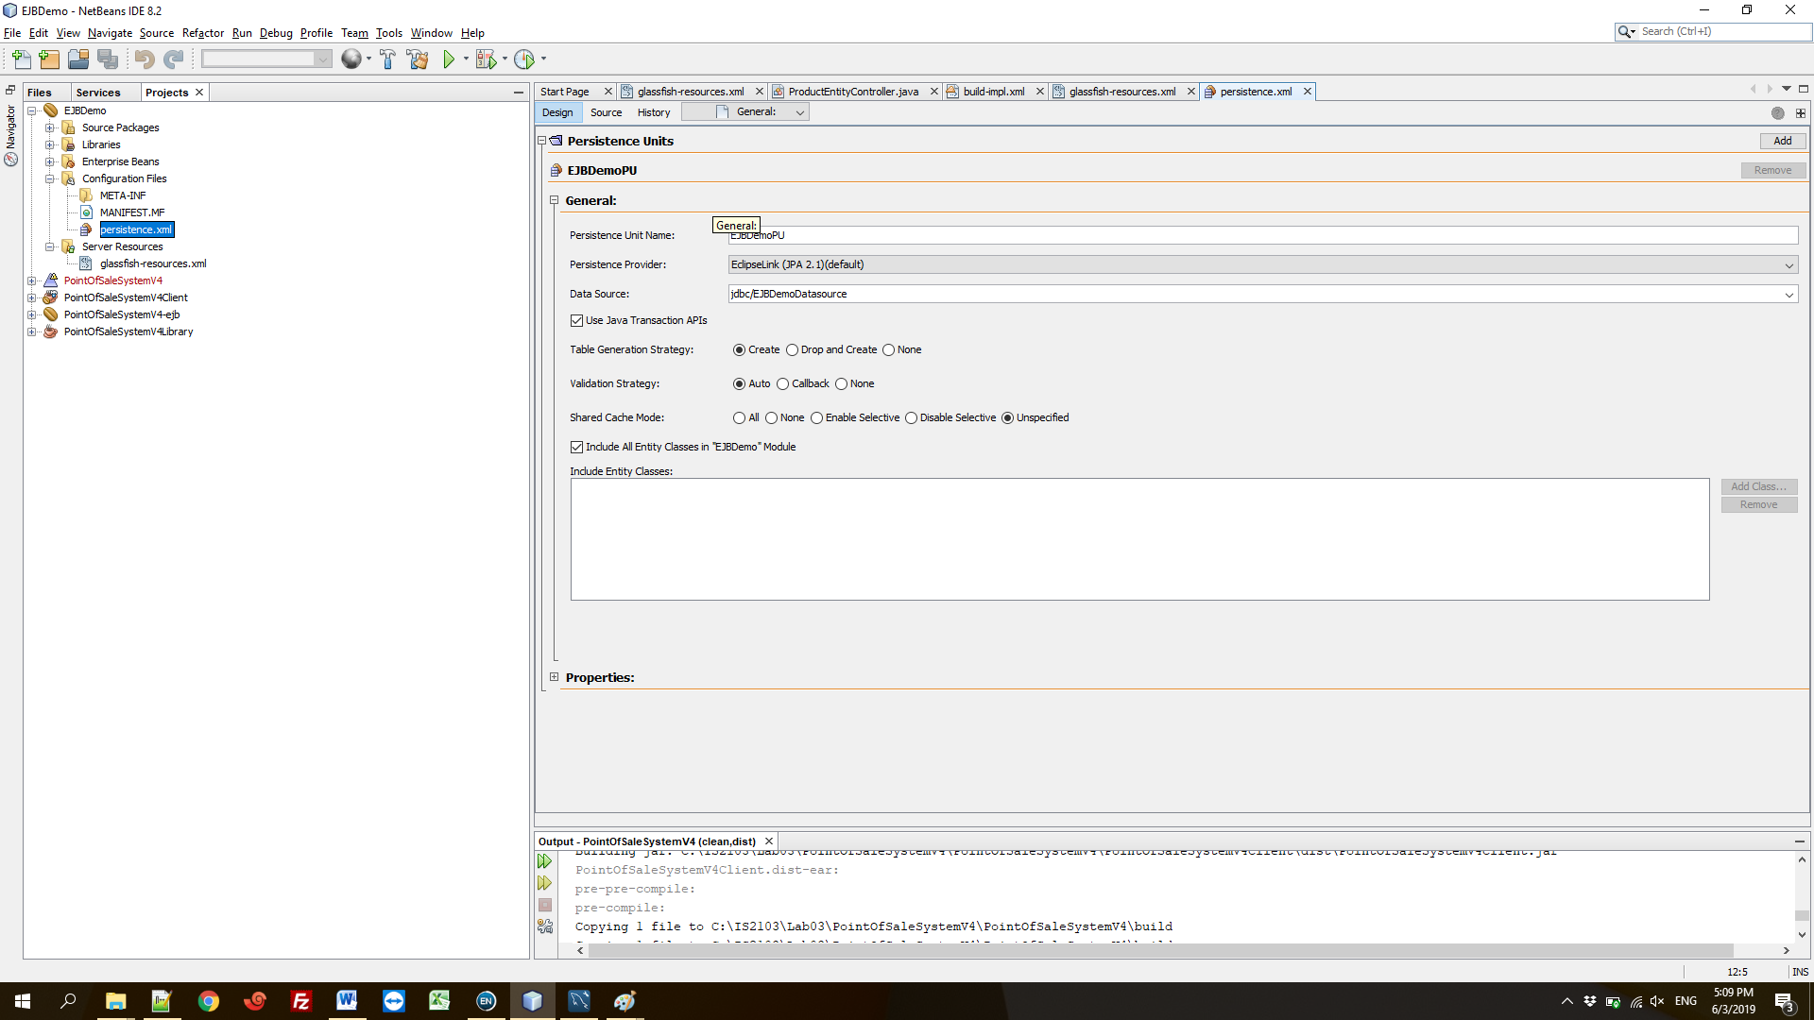

You can add the entity classes now. Untick “Include All Entity Classes in…” in persistence.xml file and click Add Class.

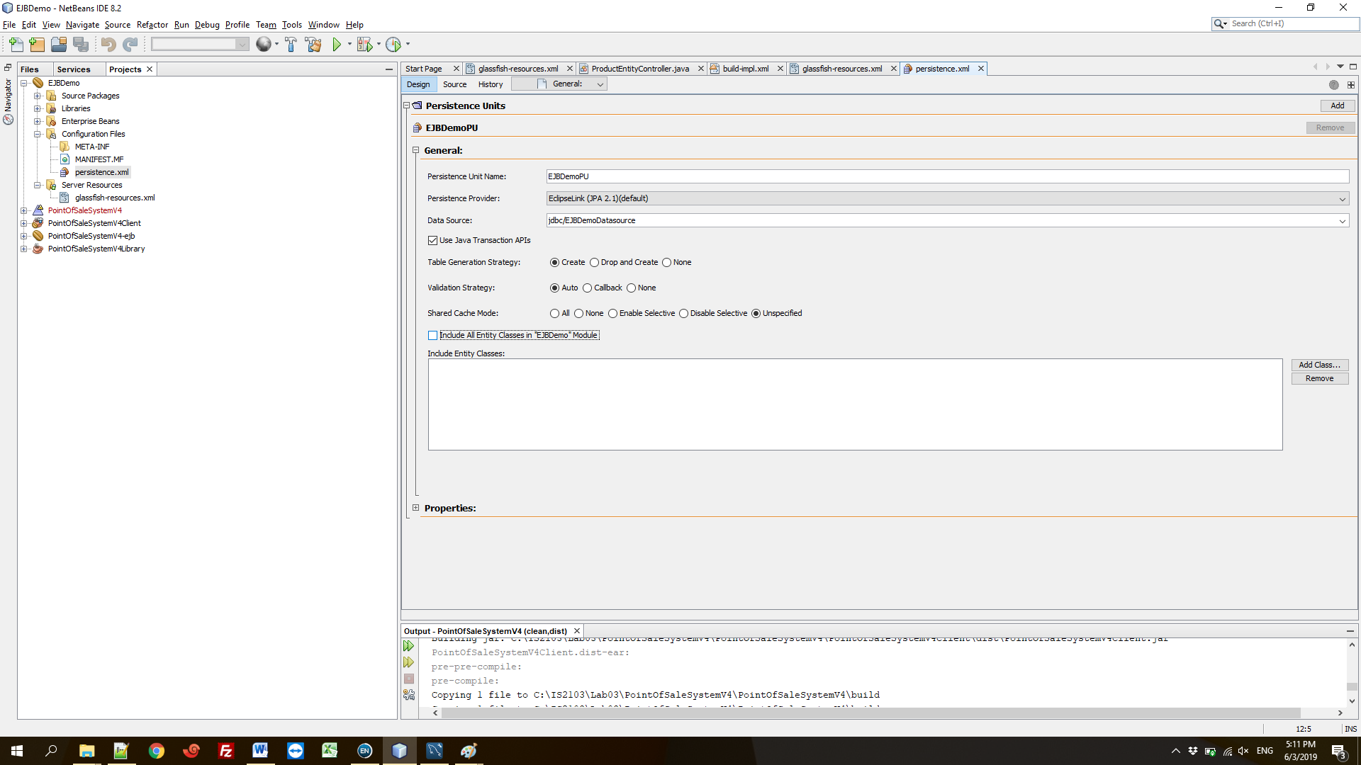

Select the entity classes (which we created in the library project). Save file.

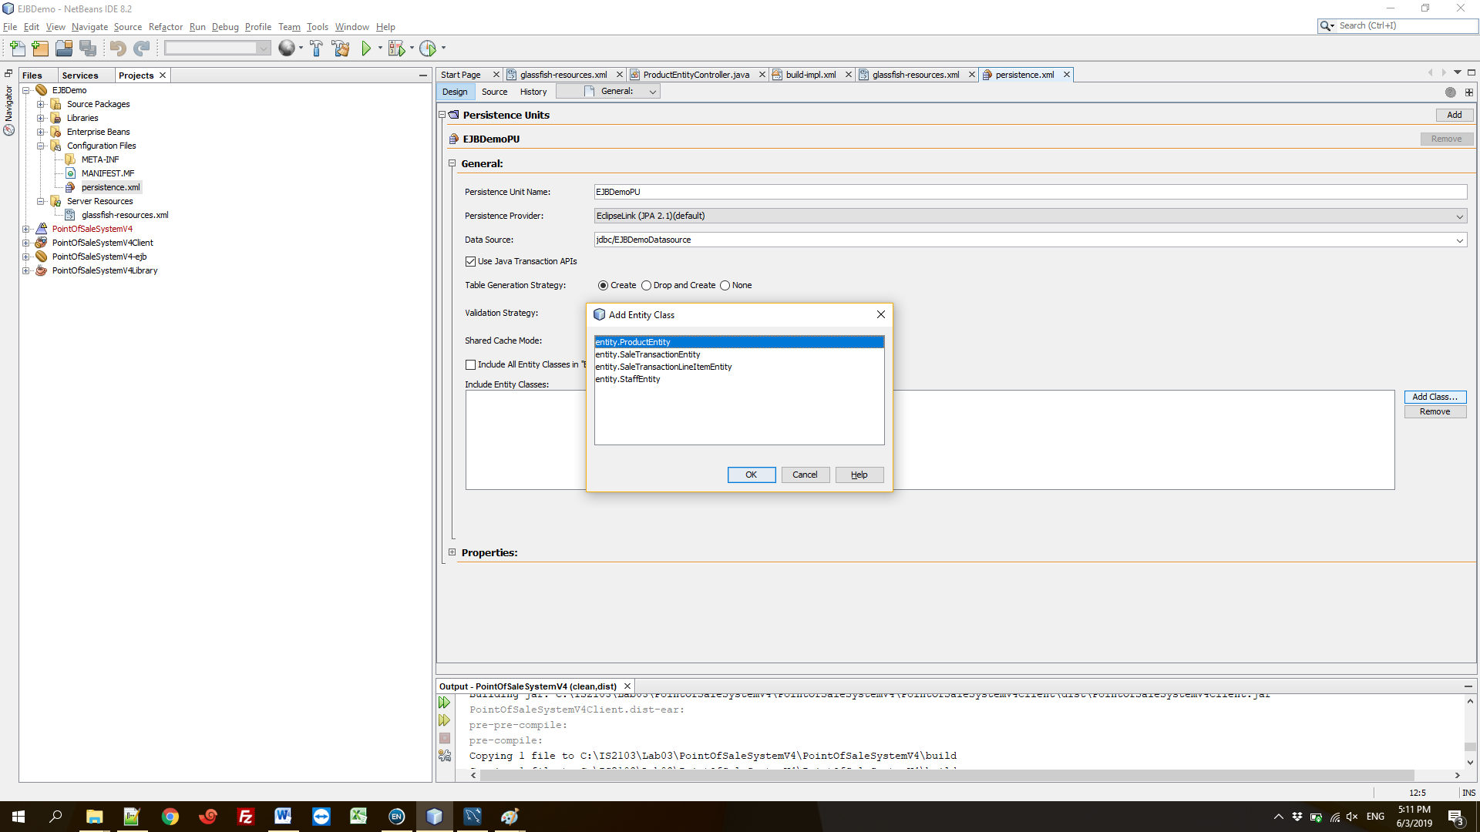

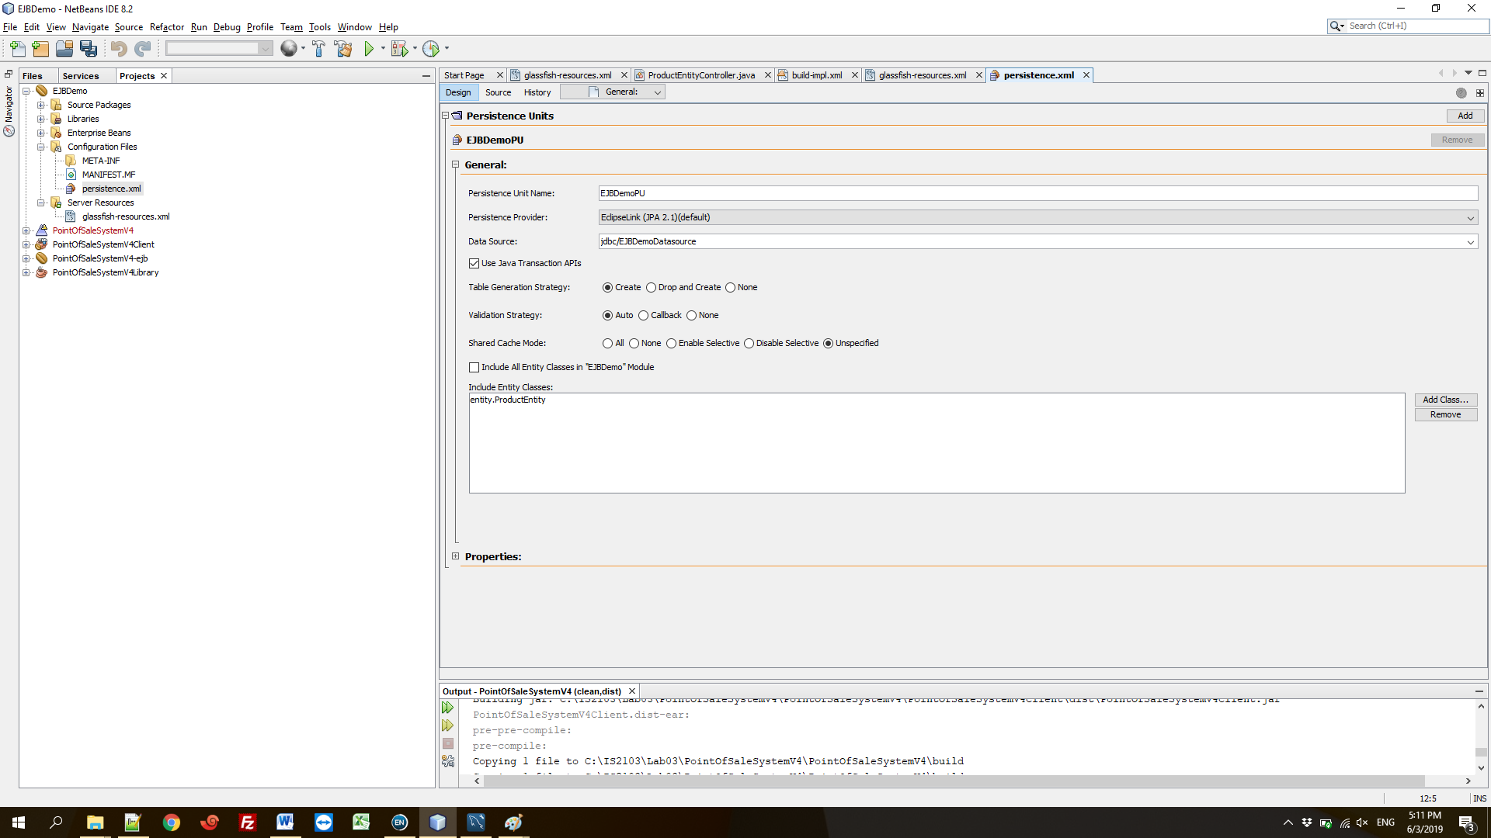

**Step 4:** Inject your persistence unit in session beans.

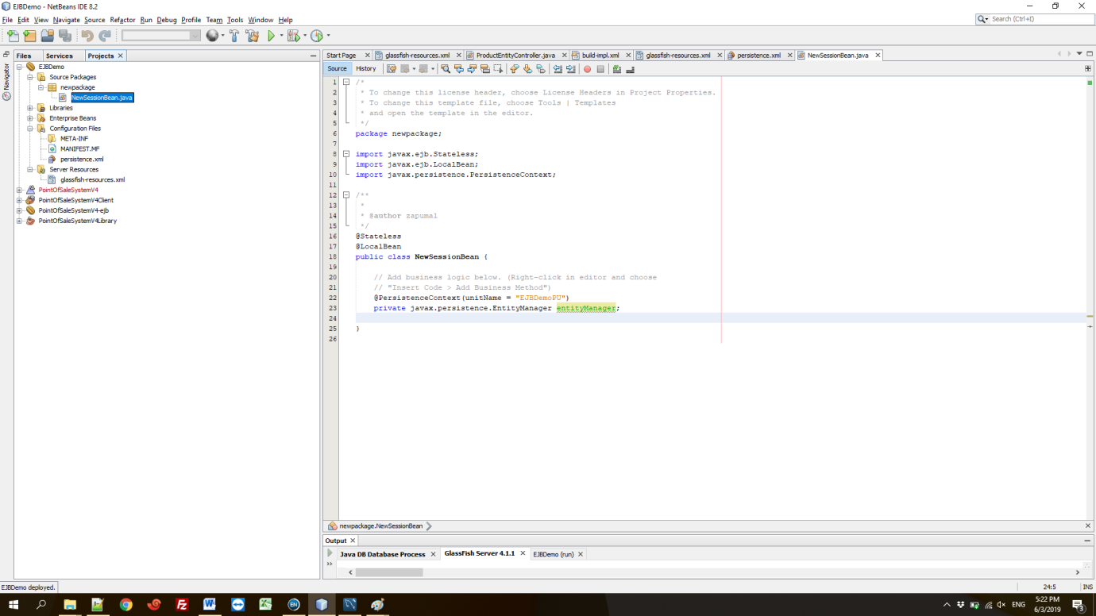

**Step 5:** Clean and Build. Deploy the project. You should see the table created in database.

